Orbost Golf Club Inc.
5th Annual Jarrah Beveridge
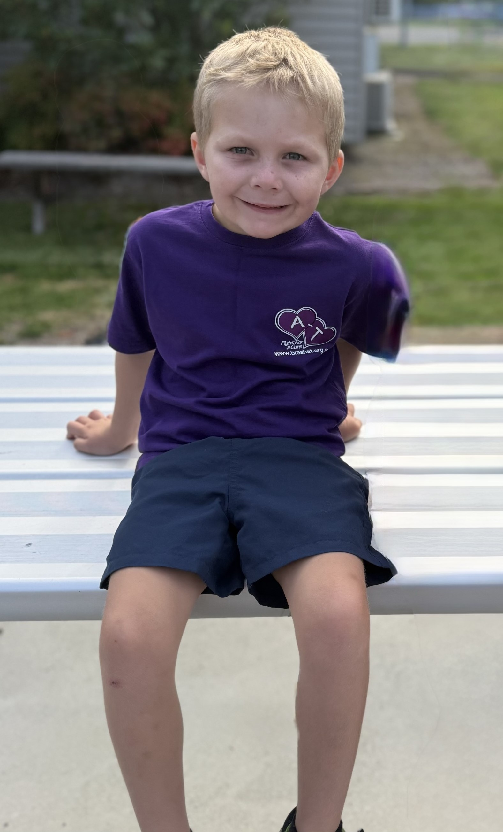
A-T Research Fundraiser

Easter Saturday April 19th 2025

Mixed 4 person Ambrose 18 holes
Men’s 4 person Ambrose 18 holes
Assemble at 9.30 am for 10.15 am Shotgun Start

Entry Fee $20 per person

All entry fees donated to the
BrAshA-T Ataxia Research Fund

All Day Sausage Sizzle
Event Organiser: 0429 938 514 Email: markglenister@hotmail.com

